**PIZZA SALES DATA EXPLORATION QUERIES AND RESULTS**

1. No of records

select count(*) from order_details;

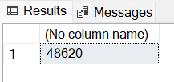

1. No of distinct records

select count(distinct order_details_id)

from order_details;



1. Period Year

select distinct datepart(year, date)

from orders;

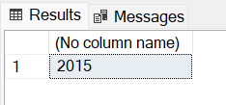

1. Does data account for all months?

select distinct datepart(month, date)

from orders

order by 1;

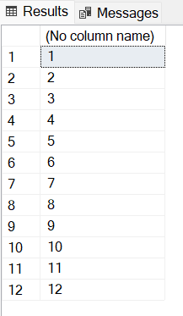

KPI

1. Total Revenue

select cast(sum(d.quantity * p.price) as decimal(10,2)) as total_revenue

from order_details d, pizzas p

where d.pizza_id = p.pizza_id

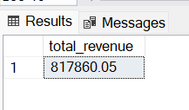

1. Average Order Value

select cast(

cast(sum(p.price * d.quantity) as float)/count(distinct o.order_id) as decimal(10,2)

) as avg_order_value

from orders o, pizzas p, order_details d

where d.order_id = o.order_id

and d.pizza_id = p.pizza_id;

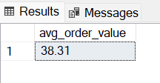

1. Total Pizzas Sold

select sum(quantity) as total_pizza_sold

from order_details;

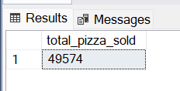

1. Total Orders

select count(order_id) as total_orders

from orders;

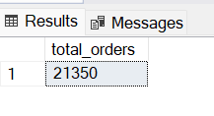

1. Average Pizzas per Order

select cast(

cast(sum(quantity) as float)/count(distinct order_id) as decimal(10,2)

) as avg_pizza_per_order

from order_details;

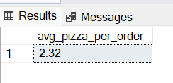

CHART REQUIREMENTS

1. Daily trends for Total Order

select datename(dw, date) as order_day,

sum(d.quantity) as no_of_orders

from orders o, order_details d

where d.order_id = o.order_id

group by datename(dw, date)

order by 1;

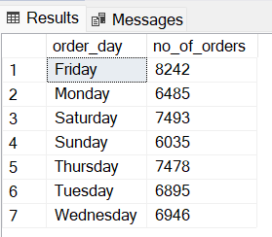

1. Hourly trends for Total Order

select datepart(hour, o.time) as order_hour,

sum(d.quantity) as no_of_orders

from orders o, order_details d

where d.order_id = o.order_id

group by datepart(hour, time)

order by 1;

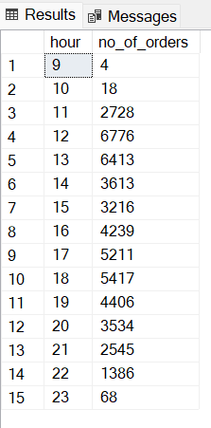

1. Percentage sales per Pizza Category

with total_sales as (

select sum(p.price * d.quantity) as total

from pizzas p, order_details d

where p.pizza_id = d.pizza_id

)

select y.category as pizza_category, cast(sum(p.price * d.quantity) as decimal(10,2)) as total_sales,

cast(

cast(

sum(p.price * d.quantity) as float

)/(select total from total_sales) * 100 as decimal(10,2)

) as percentage_sales

from pizzas p, pizza_types y, order_details d

where p.pizza_id = d.pizza_id

and p.pizza_type_id = y.pizza_type_id

group by y.category

order by 3;

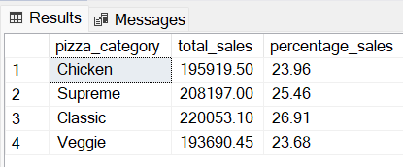

1. Percentage sales per Pizza Size

with total_sales as (

select sum(p.price * d.quantity) as total

from pizzas p, order_details d

where p.pizza_id = d.pizza_id

)

select p.size as pizza_size, cast(sum(p.price * d.quantity) as decimal(10,2)) as total_sales,

cast(

cast(

sum(p.price * d.quantity) as float

)/(select total from total_sales) * 100 as decimal(10,2)

) as percentage_sales

from pizzas p, order_details d

where p.pizza_id = d.pizza_id

group by p.size

order by 3;

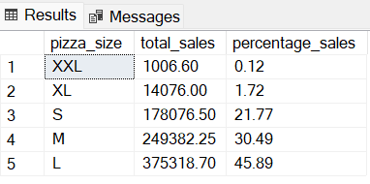

1. Percentage sales per Pizza Size per quarter

with total_sales as (

select sum(p.price * d.quantity) as total

from pizzas p, order_details d, orders o

where p.pizza_id = d.pizza_id

and d.order_id = o.order_id

and datepart(quarter, o.date) = 3

)

select p.size, cast(sum(p.price * d.quantity) as decimal(10,2)) as total_sales,

cast(

cast(

sum(p.price * d.quantity) as float

)/(select total from total_sales) * 100 as decimal(10,2)

) as percentage_sales

from pizzas p, order_details d, orders o

where d.pizza_id = p.pizza_id

and d.order_id = o.order_id

and datepart(quarter, o.date) = 3

group by p.size

order by 3;

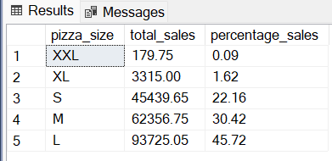

1. Total Pizza sold by Category

select y.category as pizza_category, sum(d.quantity) as total_pizza_sold

from pizza_types y, pizzas p, order_details d

where d.pizza_id = p.pizza_id

and p.pizza_type_id = y.pizza_type_id

group by y.category

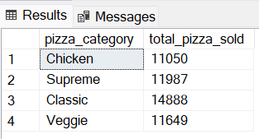

1. Top best sellers by Pizzas sold

select top 5 y.name as pizza_name,

sum(d.quantity) as total_sales

from pizzas p, pizza_types y, order_details d

where p.pizza_id = d.pizza_id

and p.pizza_type_id = y.pizza_type_id

group by y.name

order by 2 desc;

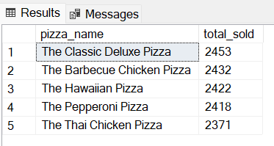

1. Bottom worst sellers by Pizzas sold

select top 5 y.name as pizza_name,

sum(d.quantity) as total_sales

from pizzas p, pizza_types y, order_details d

where p.pizza_id = d.pizza_id

and p.pizza_type_id = y.pizza_type_id

group by y.name

order by 2;

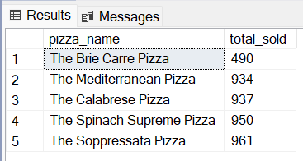

DATA TO BE EXPORTED FOR FURTHER ANALYSIS

select d.order_details_id as pizza_id, o.order_id, p.pizza_id as pizza_name_id,

d.quantity, o.date as order_date, convert(varchar, o.time, 24) as order_time, p.price as unit_price,

(p.price * d.quantity) as total_price, p.size as pizza_size, y.category as pizza_category,

y.ingredients as pizza_ingredients, y.name as pizza_name

from pizzas p, pizza_types y, order_details d, orders o

where p.pizza_type_id = y.pizza_type_id

and d.order_id = o.order_id

and d.pizza_id = p.pizza_id

order by d.order_details_id;